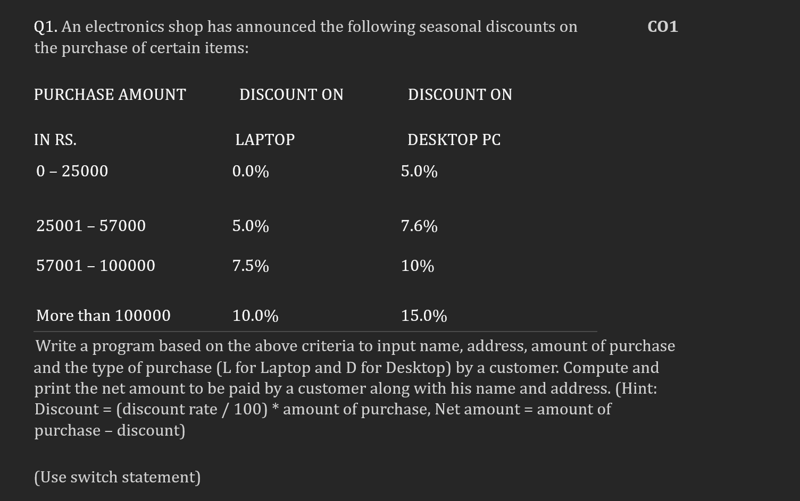
#include <iostream>
using namespace std;

int main() {
string name, address;
float amount, discount, net_amount;
char type;

cout << "Enter customer name: ";
cin >> name;
cout << "Enter customer address: ";
cin >> address;
cout << "Enter purchase amount: ";
cin >> amount;
cout << "Enter type of purchase (L for Laptop, D for Desktop): ";
cin >> type;

switch (type) {
case 'L':
if (amount <= 25000) {
discount = 0;
} else if (amount <= 57000) {
discount = 0.05 * amount;
} else if (amount <= 100000) {
discount = 0.075 * amount;
} else {
discount = 0.10 * amount;
}
break;
case 'D':
if (amount <= 25000) {
discount = 0.05 * amount;
} else if (amount <= 57000) {
discount = 0.076 * amount;
} else if (amount <= 100000) {
discount = 0.10 * amount;
} else {
discount = 0.15 * amount;
}
break;
default:
cout << "Invalid purchase type.";
return 1;
}

net_amount = amount - discount;

cout << "Customer name: " << name << endl;
cout << "Customer address: " << address << endl;
cout << "Net amount to be paid: " << net_amount << endl;

return 0;
}

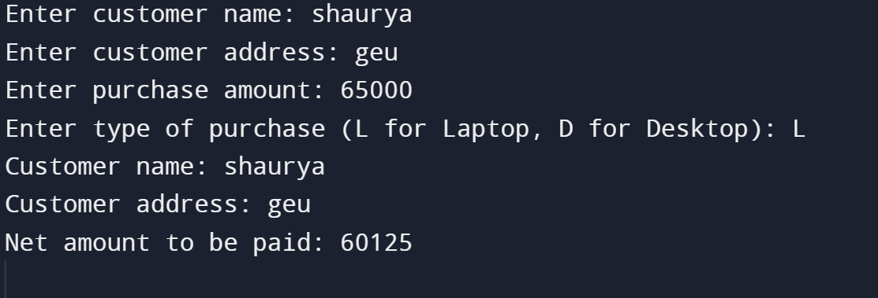

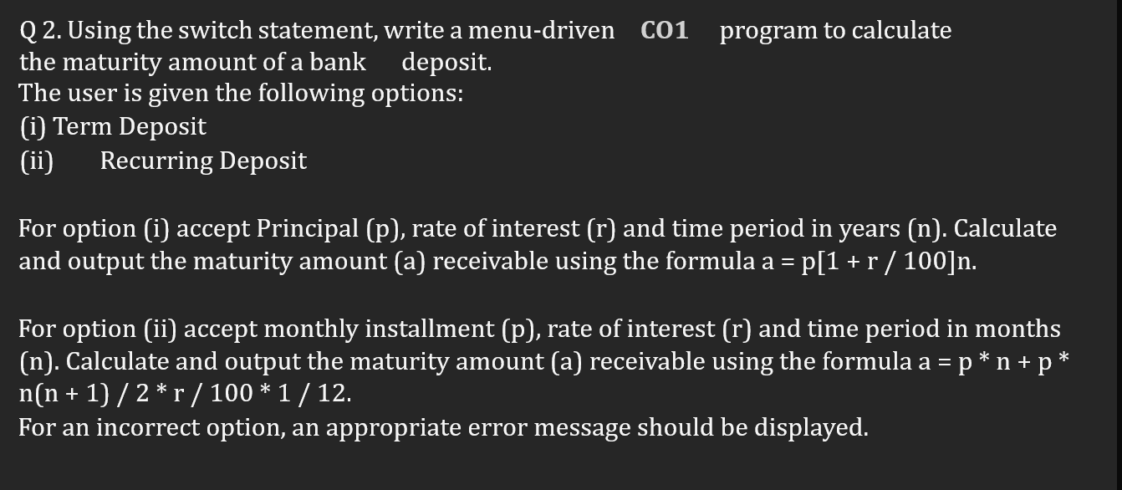
#include <iostream>
using namespace std;

int main() {
int option;
float principal, rate, time, maturity_amount;

cout << "Enter option (1 for Term Deposit, 2 for Recurring Deposit): ";
cin >> option;

switch (option) {
case 1:
cout << "Enter principal: ";
cin >> principal;
cout << "Enter rate of interest: ";
cin >> rate;
cout << "Enter time period in years: ";
cin >> time;

maturity_amount = principal * pow(1 + rate / 100, time);

cout << "Maturity amount: " << maturity_amount << endl;
break;
case 2:
cout << "Enter monthly installment: ";
cin >> principal;
cout << "Enter rate of interest: ";
cin >> rate;
cout << "Enter time period in months: ";
cin >> time;

maturity_amount = principal * time + principal * time * (time + 1) / 2 * rate / 100 * 1 / 12;

cout << "Maturity amount: " << maturity_amount << endl;
break;
default:
cout << "Invalid option.";
return 1;
}

return 0;
}

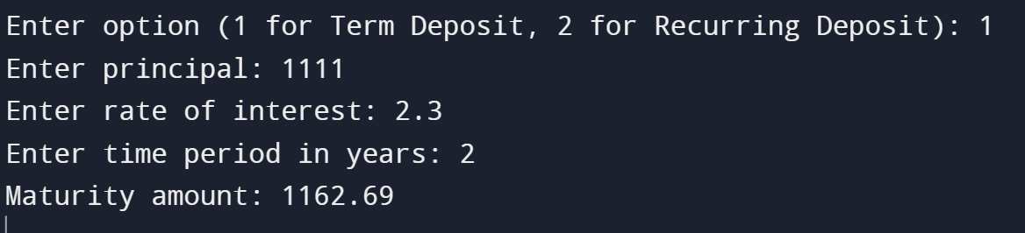

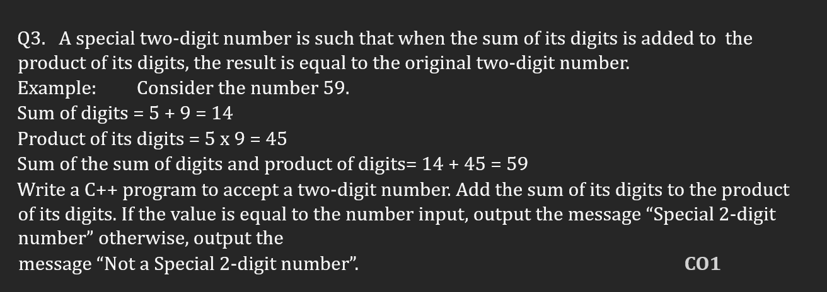
#include <iostream>
using namespace std;

int main() {
int number, sum_of_digits, product_of_digits;

cout << "Enter a two-digit number: ";
cin >> number;

sum_of_digits = number / 10 + number % 10;
product_of_digits = (number / 10) * (number % 10);

if (sum_of_digits + product_of_digits == number) {
cout << "Special 2-digit number" << endl;
} else {
cout << "Not a Special 2-digit number" << endl;
}

return 0;
}
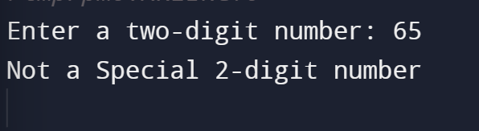

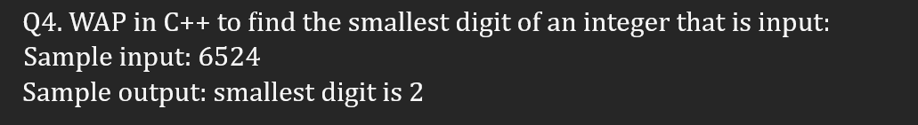
#include <iostream>
using namespace std;

int smallest_digit(int number) {
int smallest_digit = number % 10;
while (number > 0) {
number /= 10;
int digit = number % 10;
if (digit < smallest_digit) {
smallest_digit = digit;
}
}
return smallest_digit;
}

int main() {
int number;
cout << "Enter an integer: ";
cin >> number;

int smallest_digit = smallest_digit(number);

cout << "The smallest digit of the integer is " << smallest_digit << endl;

return 0;
}

Q5.
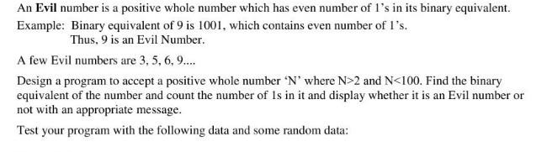

#include <iostream>
using namespace std;

bool is_evil_number(int number) {
// Find the binary equivalent of the number.
int binary_equivalent = 0;
int power = 1;
while (number > 0) {
int digit = number % 2;
binary_equivalent += digit * power;
number /= 2;
power *= 10;
}

// Count the number of 1's in the binary equivalent.
int count_of_ones = 0;
while (binary_equivalent > 0) {
int digit = binary_equivalent % 10;
if (digit == 1) {
count_of_ones++;
}
binary_equivalent /= 10;
}

// Check if the number is evil.
if (count_of_ones == number / 10) {
return true;
} else {
return false;
}
}

int main() {
int number;
cout << "Enter a positive whole number n where n > 2 and n < 100: ";
cin >> number;

// Validate the input.
if (number <= 2 || number >= 100) {
cout << "Invalid input. Please enter a number greater than 2 and less than 100." << endl;
return 1;
}

// Find if the number is evil.
bool is_evil = is_evil_number(number);

// Display the result.
if (is_evil) {
cout << "The number " << number << " is an evil number." << endl;
} else {
cout << "The number " << number << " is not an evil number." << endl;
}

return 0;
}
